The California Phenology Project: tracking the effects of climate on plant phenology through citizen science

Professor Susan Mazer
Department of Ecology, Evolution and Marine Biology
University of California, Santa Barbara

Tejon Ranch
September 13, 2014 | 9:00 am - 5:00 pm | INDICATE LOCATION HERE

Outline
Introduction
Phenology, visualizing phenological variation, linking phenology to climate change, ecological consequences of phenological change, and a few case studies
California Phenology Project: design, use of historical data, species selection for current monitoring, protocols, and a few results to date.
USA National Phenology Network: Nature’s Notebook, target species, resources available
Practical guide to setting up a public monitoring program: crash course in Botany; best practices & lessons learned

During this workshop, participants will learn how to contribute to a nationwide effort to track the effects of climate change on the timing of phenological events in plants. We’ll cover: the basics of phenology; the evidence-based link between phenological events and climate; the long-term effects of climate change on plant phenology; the risks of phenological mismatches induced by environmental change; and results of recent analyses of data collected by national park staff and volunteers in California since 2011. We will introduce the California Phenology Project (CPP; www.usanpn.org/cpp), a statewide phenological monitoring program based in seven National Parks and five University of California Natural Reserves, where 30 plant species are currently being monitored in a replicated fashion across a variety of environmental gradients. This workshop will include a presentation, on-line demonstrations, time for questions, and hands-on experience in the monitoring protocols and on-line database designed by the USA National Phenology Network (USA-NPN; www.usanpn.org). Currently, hundreds of volunteers and scientists are contributing to the NPN database standardized phenological observations of hundreds of plant and animal species.
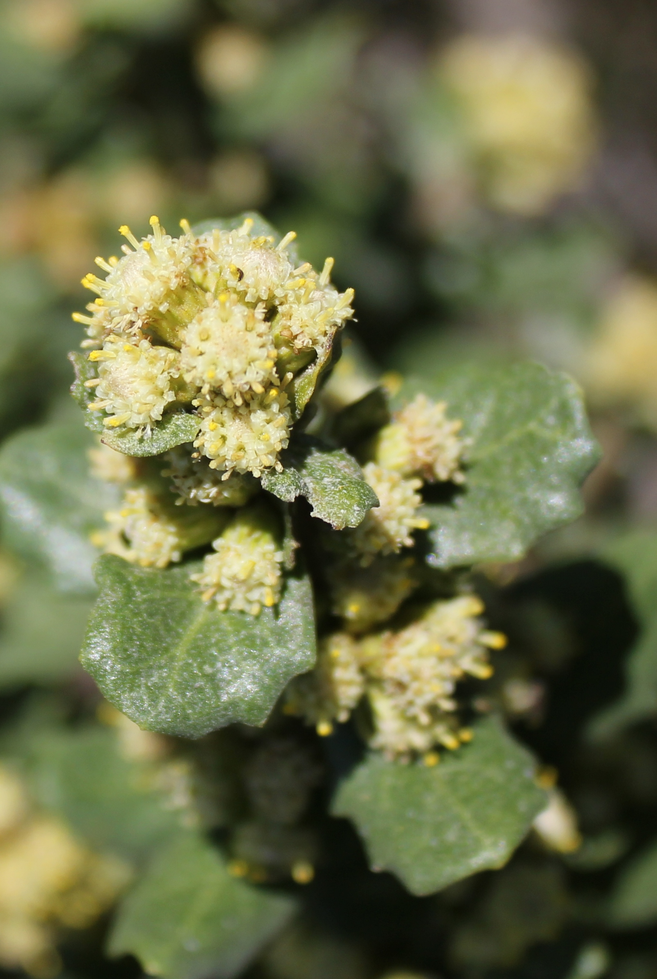 | 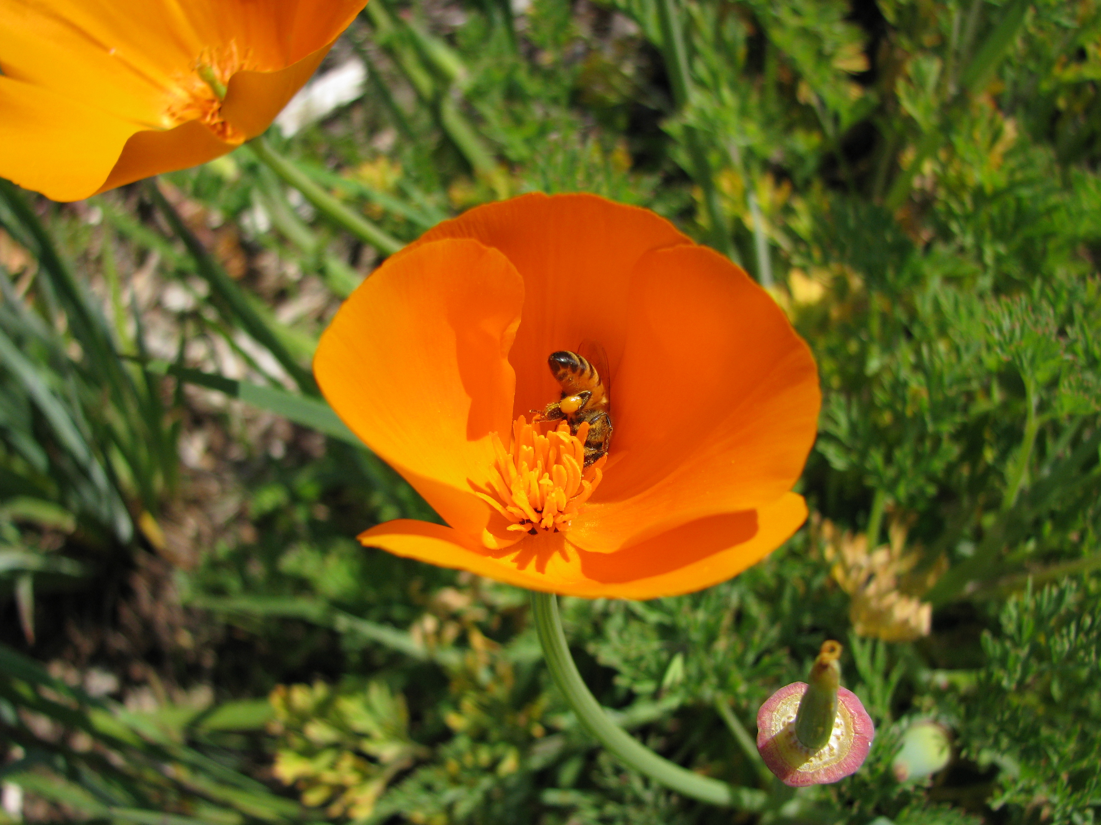 | 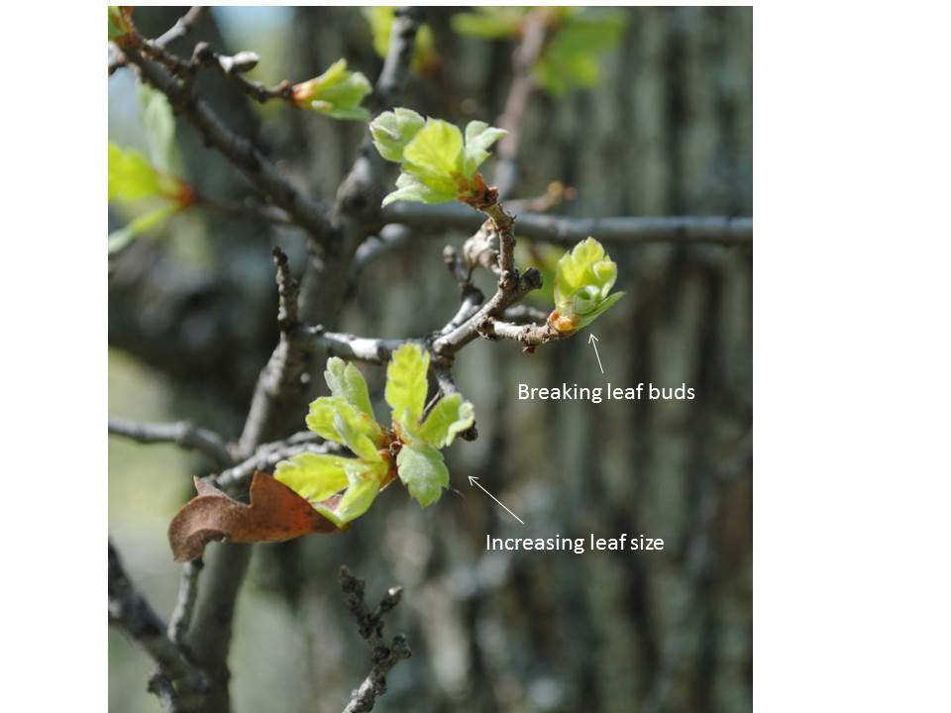
Coyotebrush, male flowers | California Poppy | Blue Oak
The California Phenology Project: www.usanpn.org/cpp
Educational materials developed by the California Phenology Project: www.usanpn.org/cpp/education
The USA National Phenology Network: http://www.usanpn.org

SELECTED ONLINE RESOURCES for climate change & phenology workshop

PHENOLOGY
USA National Phenology Network https://www.usanpn.org/
California Phenology Project https://www.usanpn.org/cpp/
Additional partners with the USA-NPN https://www.usanpn.org/partner/current

CLIMATE CHANGE
Intergovernmental Panel on Climate Change (IPCC) http://www.ipcc.ch/
C2ES – Center for Climate & Energy Solutions (formerly Pew Center on Climate Change)
http://www.c2es.org/

U.S. CLIMATE CHANGE RESEARCH PROGRAMS & RESOURCE MANAGEMENT ACTIVITIES
United States Global Change Research Program http://www.globalchange.gov
U.S. Department of Interior – Strategic Response to Climate Change
http://www.doi.gov/whatwedo/climate/strategy/index.cfm
U.S. Climate Science Centers http://www.doi.gov/csc/index.cfm
U.S. Landscape Conservation Cooperatives http://www.doi.gov/lcc/index.cfm
USGS National Climate Change & Wildlife Science Center http://nccwsc.usgs.gov/
National Park Service Climate Change Response Program:
http://www.nature.nps.gov/climatechange/index.cfm

PUBLIC PARTICIPATION IN SCIENTIFIC RESEARCH (CITIZEN SCIENCE)
Citizen Science Central (Cornell Lab of Ornithology) http://www.birds.cornell.edu/citscitoolkit

EDUCATION/OUTREACH RESOURCES
350.org http://www.350.org/
Climate Central http://www.climatecentral.org/
Union of Concerned Scientists http://www.ucsusa.org/global_warming/
Climate Science Watch http://wwwclimatesciencewatch.org
Climate Change Education http://www.climatechangeeducation.org
California Climate Change Portal http://www.climatechange.ca.gov
California Climate Change & Energy: Education Resources Catalog http://globalwarmingcalifornia.ne

