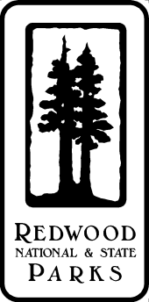**Climate Change and Plant Phenology Workshop**

**Thurs, April 10, 2014, 6–8 pm, USFWS office, Arcata\***

**Redwood National Park and the California Phenology Project invite you to attend a free workshop presented by expert phenologist**

***Plant Phenology***

***Life cycle stages, such as leafing, flowering, fruiting and senescing, and the study of their timing in relation to climate and weather.***

**Dr. Susan Mazer**

**(Dept. of Ecology, Evolution and Marine Biology, University of California, Santa Barbara)**

**With this workshop, we hope to:**

* 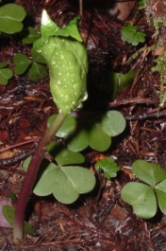**Recruit and train** volunteer citizen scientists (students may be able to receive credit) to collect phenology data at *Redwood National Park*
* **Inspire** individuals to monitor phenology in other locations (public lands, private lands, backyards)
* **Provide** materials and inspiration for bringing phenology monitoring to schools/kids as a way to teach them about climate change

**Attendees will be invited to a post-workshop field trip to see phenology monitoring at Redwood National Park in action!**

Please visit [www.usanpn.org/cpp](http://www.usanpn.org/cpp) for more information on the project.

To register for the *free* workshop (we want to have enough materials on hand), please contact: Stassia Samuels, 707-465-7784, [stassia_samuels@nps.gov](mailto:stassia_samuels@nps.gov)

* 1655 Heindon Road, Arcata - just south of the US Hwy 101 Janes/Giuntoli Road exit - From Janes Rd., turn east on Heindon Rd. at the Quality Inn, toward Toni's, turn in at the California Welcome Center and the USFWS building is the next building.