Southern California Lesson Plan
“Phenology in the Schoolyard: School Year Monitoring Project”

Educator Name: Meg Jakubowski
Date: 8.1.2013

Vital Information

Core Educational Framework: Sense of Place Interconnections Stewardship

CEF Outcomes: Team Building Personal Growth Academic Impact Stewardship

Emphases: Ecology History Climate Change
Geology Scientific Process Hydrology

Grade(s): Middle, High Indoor/Outdoor/Both: Both

Summary:
Students will monitor and record data on one plant in the schoolyard for the onset and duration of various plant phenophases throughout the school year. This data will be graphed and can be compared from year to year. Students can formulate hypotheses on causalities of similarities or differences from plant to plant or year to year as one classroom accumulates data.

Learning Objectives: Students will be able to…
- Define phenology
- Participate in a long term monitoring project, or “citizen science”
- Observe plant life cycles and phenology
- Collect long-term data on one or more plants in the schoolyard (ideally, a native plant)
- Graph and analyze the data collected
- Know or hypothesize about key abiotic factors that determine onset of plant phenophases

Key Words: Phenology, climate change, seasonal change, plants, observation, citizen science, public participation in scientific research, data collection, data analysis

Implementation

Background:
- To properly scaffold this lesson, students will need to know a these ideas and concepts.
  - Plants change from season to season. They get new leaves, flowers develop from buds to being fully open to releasing pollen and producing seeds. There may also be a period of dormancy or dieback.
  - Phenology is the “science of the seasons” – or in this case, monitoring changes in one or more plants as they respond to seasonal change.
  - Plant life cycles and phenophases are regulated by a myriad of environmental and abiotic factors. These factors include day length, seasonal change in temperatures or rainfall patterns, elevation, and latitude, to name a few.
  - Plants have life cycles; these (often yearly) stages of life – phenophases – are sequential, but not necessarily discrete.
  - Patterns of life cycles and changes in those patterns from year to year, and decade to decade, can give us a glimpse of how plants are responding to changes in weather and climate.
  - Phenology is the “science of the seasons” – or in this case, monitoring changes in one or more plants as they respond to seasonal change.
  - Monitoring plant changes in response to seasonal change is an example of “Citizen Science” or “Public Participation in Scientific Research.”
  - The more data a scientist has on how plants are behaving, the more we know about the possible present and future effects of climate change. This helps us to be proactive in managing and preparing for future changes that might occur.
- Phenology monitoring can support the following concepts in Biology:
  - Climate change and organismal response to alteration in environmental conditions
  - Variation of traits within a species, and between individuals
  - Variation in response to changes in environmental conditions (from weather to seasons to climate)
Procedure:
- Designate or choose a plant in your schoolyard. Either use an existing data sheet for that type of plant (templates for Evergreen Trees and Shrubs, Deciduous Trees and Shrubs; and Forbs (grasses/sedges/rushes) are available here https://www.usanpn.org/cpp/meet-the-species)
- Create or use an existing data sheet for your plant. Success in identifying phenophases comes from providing detailed pictures and descriptions of each phenophase that you will be monitoring.
- Determine which months you will commit to monitoring in. Obtain any permissions needed (to enter a school garden or leave the classroom with students etc.)
- Start monitoring! Upload data! Keep track of data sheets in a central location that you control access to.
- During the school year, use the large phenology calendar
- Tips:
  - Start slowly and deliberately. It will get easier, but students need to practice a bit before it will become easier for them.
  - The more students monitor, the more students will “know” their plant, and be able to distinguish changes in phenophases or plant reaction to changes in the environment.
  - Assign multiple groups or pairs to the same plant. This ensures more accurate and precise data points overall.
  - Remember – sometimes the greatest hook for a student is not when the plant reacts exactly as it is supposed to, but when there’s a “Hmmm. That’s weird; I wonder why…” moment.

Suggested Activities to Support Background Knowledge and Skills:

- Students often do not realize that FLOWERS directly lead to the formation of FRUIT and SEEDS. We often look at the male and female parts of a flower, discuss pollination as fertilization, but get so bogged down in remembering the names of the parts of a pistil that they miss the big picture!
- Print the pictures of your plant’s phenophases. Have the students put them in order. Discuss the seasonal change that your plant will go through. It sounds elementary; however, it will get them familiar with what to look for when that phenophase arises, and that the life cycle is sequential.
- Discuss, in depth, the abiotic factors that affect and regulate plant phenophases. A resource for background information is here: http://www.caltech.edu/content/caltech-science-question-month-when-do-plants-flower

Materials:
- Designate or choose a plant in your schoolyard. Some examples of native plants that the California Phenology Project is interested in monitoring and receiving your data on can be found here: https://www.usanpn.org/cpp/CPPcandidatespecies
- Data Sheets that suit your plant. You can use the CPP’s data sheets, found by clicking the plant name on the website listed above. You need both the USA- NPN datasheet and the CPP species profile for your chosen plant.
- A large poster that displays phenophases by month to record – a Phenology Calendar. Create a large poster to put on your classroom wall, or use the one provided to you.
This is one example. Another way to do it would be to go from month to month horizontally to see the changes and shifts in phenophases throughout the year.
- If you want to upload the data to the CPP website, you will need to set up an account in Nature’s Notebook here: https://www.usanpn.org/natures_notebook

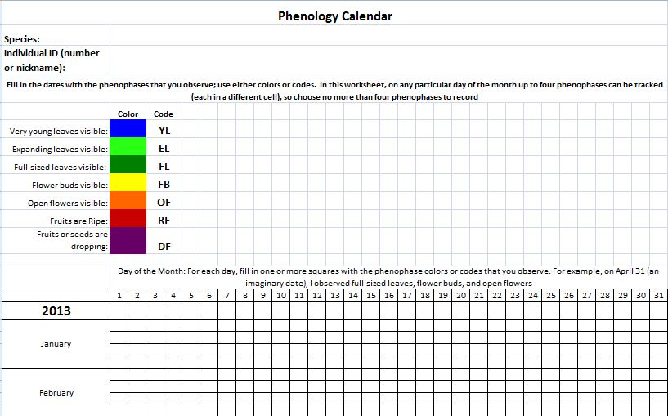
Duration: Ongoing – 30 to 60 minutes per monitoring session. Initially time consuming, after which it will be one class period per monitoring month, if that.

References:
- National Phenology Network Website: https://www.usanpn.org
- California Phenology Project Website: www.usanp.org/cpp
- Citizen Science Central Website: http://www.birds.cornell.edu/citscitoolkit
Content Standards:

- Grade 9-12: Biology
  - Ecology 6b: Analyze changes in ecosystem resulting from changes in climate, human activity, introduction of non-native species, or changes in population size.
  - Evolution 7d: Variation in species increases changes that some survive under changed environmental conditions.
- NGSS
  - Dimension 1:
    - Planning and carrying out investigations
    - Analyze and interpret data
    - Constructing explanations (science)
  - Dimension 2:
    - Patterns
    - Cause and effect
    - Stability and change
  - Dimension 3: Core Ideas
    - LS 2: Ecosystems: Interactions, energy and dynamics
    - LS 3: Heredity: Inheritance and variation of traits
    - LS4: Biological Evolution: Unity and diversity

